**Final Report: TR3202**

**Timothy Hou**

**A0108426J**

**Company: Waterfall Security Solutions**

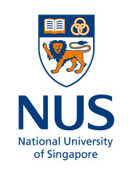

**Executive Summary**

Update on company and internship focus: Since I started, Waterfall Security Solutions has employed more people, and started to expand the team in all departments, from the hardware, to software, to sales and marketing teams. In terms of external developments, we are moving into Indonesia in terms of APAC region. Also, we are adding more and more features into the product which will keep and grow a larger customer base.

Internship Details: My main role being in DevOps, was to support the development teams. To that end, I oversaw two main projects, implementation and maintenance of EasyRedmine, and Gerrit softwares, to be used by the product development team. For these projects, I picked up Linux server administration via virtual machines, networking, bash scripting and python language, setting up proper build/testing and production environments.

Personal Growth: Of course, being in unfamiliar overseas environment has improved a sense of personal responsibility, as well as having to pick up skills such as cooking, learning programming languages in my spare time, always having a sense of curiosity and love of learning, thinking about problems which society faces, and thinking of ways to solve it. These skills and mindsets helped me to adapt to and thrive in these past brief, but fast paced months, and which I never would have cultivated if it were not for this opportunity. Being in the TAU program was a privilege as it gave me lots of exposure, both in theory and practice to how the startup ecosystem is like, from the ideation to the funding to the customer acquisition process. At the same time, being students, we had the chance to interact with the student community, which included other exchange students as well, in both informal and formal settings, and we learnt much about both Israel as a nation, and everyone’s opinions of it.

Entrepreneurship focus and outcomes: One of the most promising ideas we have had is The Magic Cookbook. Simply put, it is a mobile application that accepts ingredients as input, and shows a list of recipes based on it. It was warmly received in the phase of market validation, and we managed to get funding for developing the idea post internship. One way the program can improve is to provide prototyping tools and knowledge to construct mockups, prototypes or even Minimum Viable Products (MVP), so that each team would be able to bring out their ideas in some physical form, as opposed to using slides all the way.

A. Updates on company and internship focus – Have there been any major changes at the company since you started? What about changes in the market or industry that have impacted the company? What are your views on these, whether from the technological perspective, or from the business angle? Alternatively, compare your understanding of the company, its industry or product/s from the time you first started, to how you view them now, as you prepare to complete your attachment. Reflect on the factors that have shaped your perspective.

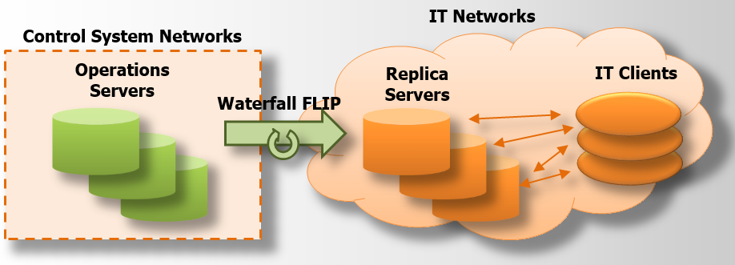Fig 1

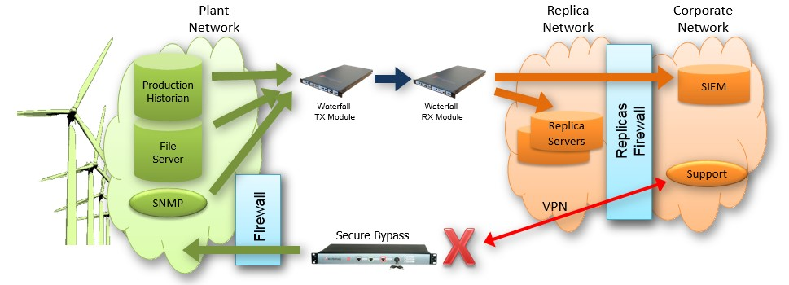

Fig 2

Our focus is still in Singapore, Korea and Japan, however we are trying to expand into Indonesia. As countries develop, the amount of critical infrastructure that it needs increases, and so the market demand for Waterfall products for cybersecurity increases. From a technological perspective, I noticed that Waterfall is branching into other sectors requiring cybersecurity now. This is because it has come up with the FLIP (Fig 1) and secure bypass (fig 2), both of which are deployed in sectors which it is considered a calculated, yet permissible risk to switch from a private network communication to a public one for a short period of time. The original product had no such features, and is considered extremely secure, but for the price of inconvenience. It is being deployed in ultra-critical infrastructures such as nuclear, and power generation plants. The newer products would be deployed in other areas like business networks, or in emergency situations which permits remote access.

When I first started, I viewed the company as one which worked on arcane technologies, having been exposed to the ‘latest’ trends in technology development, especially widespread usage of python and big data analytics. Right now, I have come to a greater and wider appreciation of software development, that software is not just about the latest trends, but it is about robust, stable design as well.

Internship Details

Throughout these past few months, my role has primarily been to support, and improve the product development process of Waterfall, by first, improving the code building and testing environment that the product development team works in.

DevOps

As seen from the diagram above, it gives a quick overview of the general teams that make up the product development team, and the relationships between them. In the initial stages of every product lifecycle, Hardware will come up with the electronic and mechanical designs, and they will send it to R&D, which will develop software in it, and send the complete package to QA for final testing and evaluation. QA will send it back to R&D when it finds issues or bugs that need to be resolved, or features it suggests to add on to enhance the product. The cycle goes on until there is a consensus that the product is ready for customer usage. Throughout the entire lifecycle, DevOps exists in order to streamline, and speed up the workflow, in order to get the product to market quicker, but still with consistent quality. This is my role in the company, which has remained constant throughout the attachment, and I have carried out two main projects which is representative of that role, namely the implementation of Easy Redmine, and Gerrit softwares for the entire team to use.

Firstly, Easy Redmine. What we needed it for was, to keep track of the increasing numbers of bugs and crashes recorded by QA during testing stage and actionable items to be followed up on by R&D team during debugging and product improvement stages. It was also used to propose and keep track of the progress for new features and upgrades either for existing products, or for the next line of products. The strength of Easy Redmine was that it contained all the tools needed for project management in an easy to visualize and organize data format. The decision was made to adopt it because we are expanding, in terms of people and products, and it presented an upgrade over the previous project management system Trac in terms of project management capabilities.

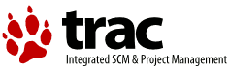 

As shown from the diagram above, we could not simply download, install and use Easy Redmine. We had to migrate the existing data we had built up in trac, which was years worth of development projects and issues, and port it over to Easy Redmine. While there was a script provided by the Redmine team to aid in this migration, but it was written in Ruby, which me and my supervisor Tal had no experience or exposure in using. This was compounded by the fact that there were customized data formats in Trac, which the developers wanted to keep when they moved it over to Easy Redmine, and so we had to figure out the inner workings of the migration script in order to make the customizations for the development team. It took about three months, but we finally got every thing in working order and implemented it. After which, part of my job was to continually maintain the website, make custom improvements, and instruct the website users on how to navigate the User Interface.

The next project I undertook was to implement Gerrit together with Git. For any professional development team, version control is a much needed tool to produce reliable and robust software in an optimal amount of time. Git is one of the most popular softwares in the development world for version control, and this is what the waterfall software development team is using currently. Part of my task was to integrate Gerrit as a User Interface (UI) together with Git as an enhancement to the development workflow. The main attraction of Gerrit is that it is a code review system, which meant that their code would be checked into the UI, and subject to further approval by team leaders before integrating it into the Git system, which contains the actual production code. The expectation was that better quality code could be produced, which is vitally important as Waterfall expands its range of products.

The difficulty here was getting Gerrit to work together with the existing workflows. Currently the developers were using TortoiseGit, a (Graphical User Interface) GUI based version Git based on Windows. I had to write a script to reconfigure the settings in the TortoiseGit client of every developer to work with Gerri. Also, for automation purposes, we were using Jenkins, an automated build software platform, to automate a daily building and deployment of a central Waterfall Installer package, which is the main software package needed in the Waterfall products. Previously, Git was hosted on a different server, and now that I hosted Git on another server in conjunction with Gerrit, I had to synchronize the data so that there would be no data loss when moving from one server to another. At the same time, I had familiarize myself with Jenkins in order to reconfigure it to take the code for building software from the new Gerrit server instead.

Technically, I have learnt to work with multiple existing technologies which are built using a variety of unfamiliar tools and processes, and I had to learn how to abstract and generalize the code in and usage each software, in order grasp the fundamentals succinctly and quickly. As part of the job, I had to learn to be comfortable in deploying and administering Linux servers, primarily on virtual machines, and how to maintain them if they crash during work hours. In the process of learning how to work with Linux, I have picked up bash and python scripting, which helped to automate and speed up certain autonomous, or rather, laborious processes.

On the not so technical side, I have learnt to place customer needs first and focus on understanding their goals and mindsets before embarking on any kind of action, or to better improve the projects I am undertaking, or have undertaken. In this case, my customers are Waterfall Security Solutions product development team, and having many different teams for different purposes really helped in honing my understanding skills. At the same time, because I had to learn about many unfamiliar technologies in a short time period, I learned how to learn, and I grew to love learning as well.

Personal Growth

Being in Israel has ‘forced’ me to go out of my comfort zone. One thing I have learnt from the Israelis is always to be direct and upfront, and not to be too concerned about offending others. Being able to speak your mind, and not having to worry about the thoughts and feelings of others is a self-development skill. Also, as foreign students, we need to rely on Israel’s public infrastructure for our daily needs. But services such as transport, health, housing, the execution level of predetermined plans are not what we are used to. Coupled with the fact that many of the signs, guides, and directions are in Hebrew and Arabic, this can create messy situations, or as the Israelis call it: ‘balagan’. We were constantly spurred on to develop a mindset of being able to adapt and react quickly to changes in surroundings and situations, and making decisions based on the limited information available to us at that point in time. Having such a mindset helps us in entrepreneurship, especially in starting a business, where market conditions, and company focus changes frequently.

In part because of my work experience, I grew to love learning, as well as perfecting the art of learning, and absorbing new amounts of knowledge all the time. This has led me to go to certain meetups, as well as take up two part time online classes, one on C programming language, another on philosophy. Being able to learn quickly, and to love learning, is a valuable skill for any entrepreneur wishing to startup a business. Although startup founders may have a certain special expertise to contribute, they are not relegated to being one-trick ponies, and having to take on all sorts of roles in the initial stages of a company is one of the factors for success.

The TAU program was really helpful in terms of thinking about how to conceptualize a business model, and how it works together with the targeted market. I really appreciate Professor Noga’s efforts to expose us to the entrepreneurship ecosystem. On top of that, being a well-connected venture capitalist, she has brought in high ranking officials, who are from the public sector, active entrepreneurs, and so on in order to expose us to the different factors that affect the startup scene, thereby broadening our perspectives. Her lectures gave us a bird’s eye view, and pointed us in the right direction when deciding on a good business model. Coupled with another module on market validation, this semester deepened and widened our knowledge on what starts, and grows a business. At the same time, she took the effort to personally do a one-on-one consultation with all the teams for the final presentation in order to straighten out their pitch performances, and give each of us valuable advice if we were to take our ideas and turn them into profitable businesses.

Also, being in TAU, we had the opportunity to go to formal and informal events organized by campus, where we met other exchange students, and other local students. Because Israel, much like Singapore, is a land of immigrants, we managed to learn much about, and appreciate the cultures and backgrounds of everyone. Each individual we met had a unique story to share with us, and I think we took a sense of the world being much bigger than what we originally thought, and with that sense, we walked away being humbled. On top of that, one of the best opportunities we ever had, was to live with a local Israeli student in the rented flat. Staying with him, we got to truly know, and listen to the stories of what the man-in-the-street faces each and every day in Israel. It was a unique experience. As a budding entrepreneur, it taught me that, in order to understand our customer base, we have to use our products as they use it, and understand their rationale, their mindset, and their attitudes.

D. Entrepreneurship focus and outcomes – Having been immersed in a highly creative and entrepreneurial environment for half a year, what innovative products/technologies or business ideas have come to mind? Please share one of these ideas in some detail. How do you intend to pursue or develop it, post-program? In your opinion, what else can be done during the program to facilitate exploration and experimentation in this regard? How should the program’s assessment methodology be improved so as to enable interns to more concretely measure the extent of their learning and transformation?

-focus on other areas, all-roundedness (1 week of another guy’s job)